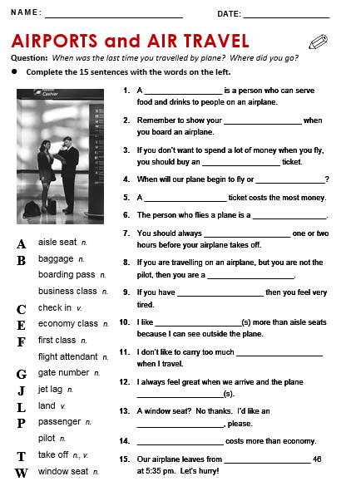

1. Flight attendant
2. Boarding pass
3. Economy class
4. Land
5. Business class
6. Pilot
7. Check in
8. Passenger
9. Jet lag
10. Window seat
11. Baggage
12. Takes off
13. Aisle seat
14. First class
15. Gate number